

**February 2020 Newsletter**



**Sponsorship**

**Calling all members …..**

if you have workplace contacts, or know of companies or individuals who may be interested in a sponsorship package with the Club, we would like to hear from you.

Sponsorship can take many forms, e.g.:

* Banners on the netting round a court
* Sponsor’s logo on noticeboards, newsletter, membership forms etc.
* Advert on the club website, social media channels
* Sponsoring team kit – logo on the kit
* Sponsor’s logo/advert displayed courtside during coaching sessions

If you have any suggestions/thoughts please contact the club on [info@blackburnnorthern.co.uk](mailto:info@blackburnnorthern.co.uk) with **“Sponsorship”** as the subject.

**The Committee**



**February 2020 Newsletter**

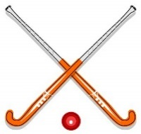

**Hockey**

**Mid-season Resume**

**Ladies 1st team** in North West Hockey league Div 2

W 2 D 2 L 12 Position 12th

It has been a very tough season for the 1st team, Having won promotion last year, their team has been affected by injuries etc.

**Ladies 2nd team** in Lancashire Central League Div 1

W 10 D 3 L 4 Position 2nd

**Ladies 3rd team** in Lancashire Central League Div 2

W 12 D 1 L 3 Position 2nd

**Ladies 4th team** also in Lancashire Central League Div 2

W 6 D 2 L 6 Position 6th

Special mention must be made of **the 4th team**, which is mainly comprised of juniors, so to be 6th in the division is a great performance.

The Club has the most promising set of juniors in a long time, both boys and girls. They are coached by **Hannah Laverty- Metcalfe** and through her encouragement and expertise the juniors are becoming great young players for the club. The junior U13 and U15 teams have built up an excellent reputation in the Badger League. Well done Hannah and the juniors!

**Mens 1st team** in North West League Premier Division

W 9 D 2 L 6 Position 4th



**February 2020 Newsletter**

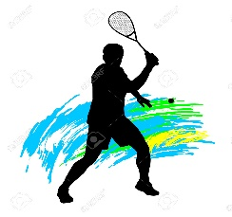

**Squash**

**In the Summer Squash:**

**1st team** Central North League Div 3

The team have only lost 1 match Position 1st

**2nd team** Central North League Div 4

The team have only lost 1 match Position 1st

**3rd team** also Central North League Div 4

Position 4th

**All teams are performing brilliantly! ……**

……. and In the local derby v East Lancs, we are really pleased to be able to report that **“bragging rights belong to Blackburn”.**



**Tennis**

The Club play in the **East Lancs Mixed Winter League** and the standings at the moment are as follows:

A team 1st Div 1

B team 3rd Div 1

C team 2nd Div 2

D team 3rd Div 3

Fair to say the club’s teams are having a very successful winter season!

**Outdoor Tennis Court Floodlights**

Members may have seen that recent high winds have caused substantial damage to one of the lights, resulting in the far two courts having to be closed for safety reasons.

Due to the deteriorating condition of the floodlights, they are going to have to be taken down. **The work is due to be carried out in February, after which the courts will be back in use.**

**February 2020 Newsletter**

